Course Copy Help Guide for Blackboard
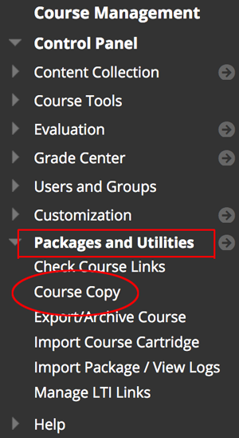
You can quickly copy your course from one section or semester to the next, instead of starting from scratch each time.
- Always start in the course that has the content you want to copy (e.g., when copying from Fall to Spring, go into the Fall course).
- In the Control Panel, click Packages and Utilities to expand it.
- Then select Course Copy.
- For the "Destination Course ID," click the Browse button.
  - In the window that pops up, select the desired course (i.e., where you want the content).
  - Pay attention to the 6-digit term code at the beginning of the Course Name to ensure you select the correct one. Or use the search at the top to find a specific CRN.
  - Then click the Submit button at the bottom.
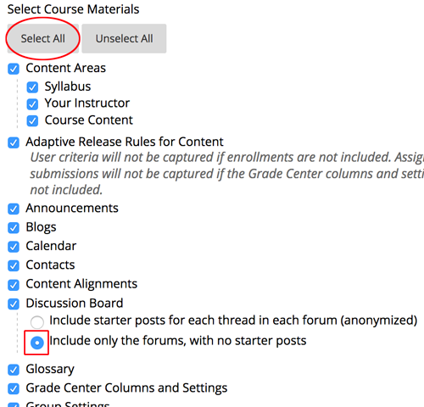
- In the Select Course Materials area, click the Select All button.
  - NOTE: Do NOT pick and choose individual items as this can cause issues with things not copying properly, particularly with regard to the gradebook.
  - If you had discussions in your previous course, you may want to switch the Discussion Board option to “Include only the forums, with no starter posts” so all of your previous students’ threads are not copied over.
- Keep the File Attachments area with the default option of “Copy links and copies of the content” so all the files being used are copied over.
- Click Submit.
You will receive an email after the course copy process is complete. Please do not copy any other courses until after you get that email, because it can cause errors in the copy process.
NOTE: Course copies always happen in addition to whatever is already in the destination course and never replace it, so make sure you do not copy into the same shell multiple times.

Tips
- Blackboard Section Merge form – If you teach more than one section of the same course, you may want to merge them into one course in Blackboard. Please request the merge prior to copying/adding content into your course shells and prior to student enrollments.
- Date Management – After you’ve copied your course, use the Date Management tool in Blackboard to quickly move the availability and due dates forward or to edit them.
- Grade Center – You might need to clean up some of the total columns in the gradebook to make sure you don’t have duplicates.
- Copy Logs – The course copy logs are helpful to see if you’ve already copied the course, which course you copied, and to make sure things copied properly. To view the log of the copy, go into the course and then go to Course Tools > Packages and Utilities > Import Package / View Logs. Click the link for your copy and look at the summary at the top to see if there were any critical errors.
- Multiple Copies – If you accidentally copied a course into a shell more than once, please contact an Instructional Designer in Distance Learning to have the course materials bulk deleted. Then you can start over with a fresh copy; this is much easier and faster than trying to delete all the duplicates.

Need Help?
Contact one of our instructional designers.

